**Lab 02 - Regression**

W.L.K.D.D.A.Wickramasinghe

210711T

.

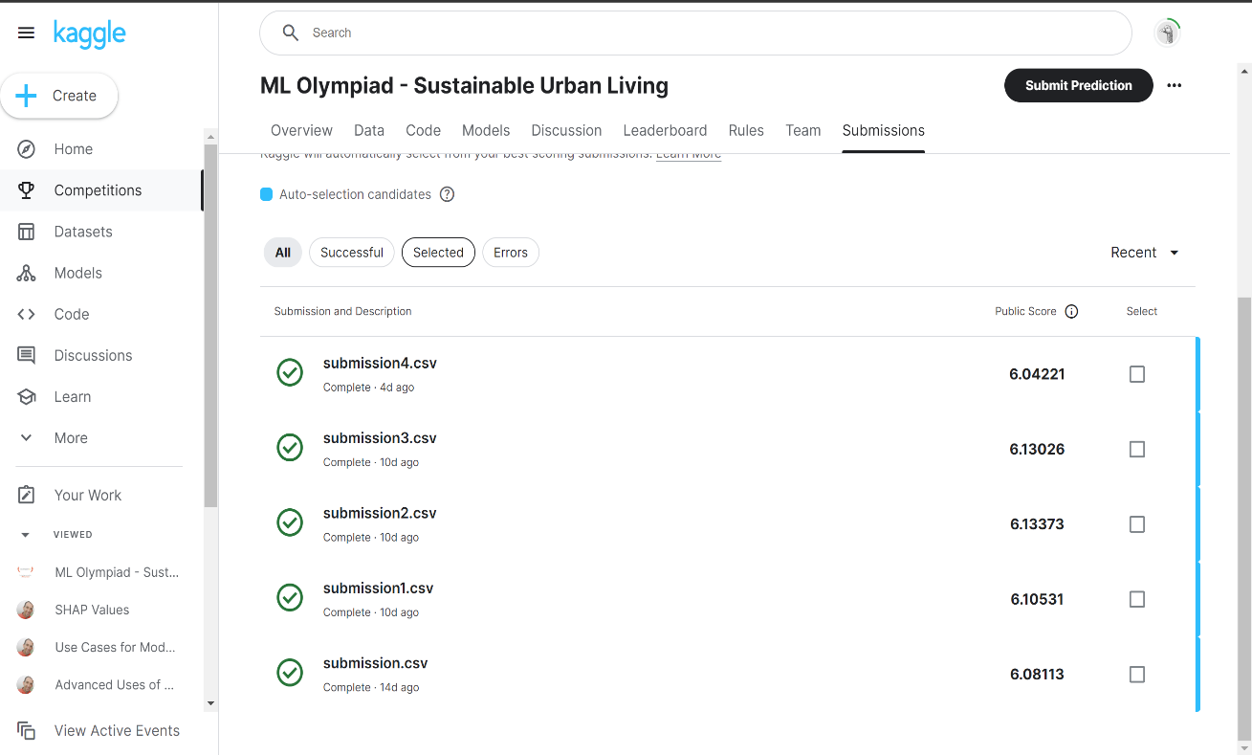**Proofs of the Submissions**

**Score and the rank.**

